

PLANT DISEASE DETECTION

Student Name: MURALIDHAR DIVAKAR
Student Number: 25255674
Course: CS618[A] – Deep Learning for Software Engineers
Lecturer: Mr. Mark McCormack

PROBLEM DEFINITION

The goal of this project is to automatically detect diseases in plant leaves from images. Early and accurate detection of plant diseases is crucial for improving crop yield, reducing economic losses, and enabling timely intervention. Traditional methods rely on manual inspection by experts, which is time-consuming, subjective, and not scalable for large farms.
Deep learning, particularly Convolutional Neural Networks (CNNs) like MobileNetV2, is well-suited for this task because it can automatically learn complex patterns and features from images without the need for manual feature engineering. CNNs have demonstrated high accuracy in image classification problems, making them ideal for identifying subtle differences in healthy and diseased plant leaves. By leveraging deep learning, this project aims to provide a scalable, fast, and accurate solution for plant disease detection.

Objective
To develop a deep learning model capable of accurately detecting plant diseases from leaf images, supporting early diagnosis and improving crop health management.

Dataset
- Source: Kaggle dataset “emmarex/plantdisease”

- Content: Images of plant leaves labeled by disease type.
The dataset was organized into a clean directory MultiCrop_9 containing only the relevant classes.
- Data Preprocessing: Images resized to 224x224 pixels. Data split into training (80%), validation (10%), and test (10%) sets.

- Model Architecture: A MobileNetV2 model pre-trained on ImageNet was used as the base, with the top layers removed. The base was frozen, and additional layers were added:
- GlobalAveragePooling2D.
- Dropout (0.3).
- Dense layer with softmax activation for classification.
The model was compiled with Adam optimizer (learning rate 1e-4) and sparse categorical cross entropy loss.
Selected classes
- Tomato_healthy
- Tomato_Early_blight
- Tomato_Late_blight
- Tomato_Bacterial_spot
- Potato classes
- Pepper classes

Models
The following models were used:
- CNN – baseline model for feature extraction.
- MobileNetV2 – lightweight pre-trained model for efficient deployment.

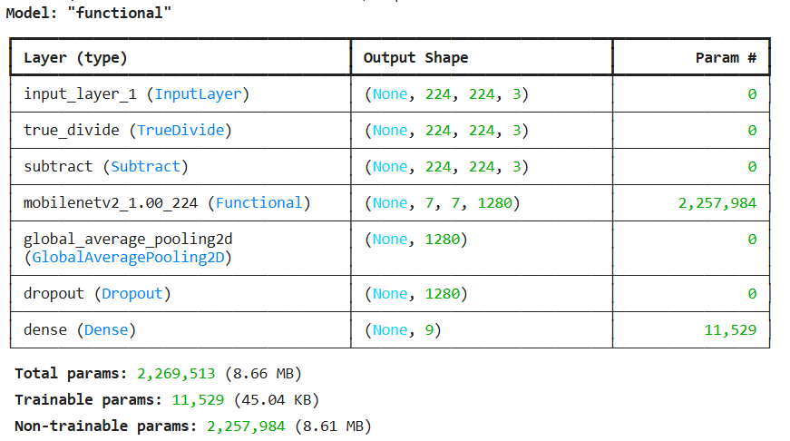
Fig: Model Summary

Training
- Optimizer: Adam (learning rate = 1e-4).
- Loss Function: Sparse Categorical Cross entropy.
- Epochs: 10 epochs.
- Batch Size: 32.
- Techniques: Transfer learning applied for MobileNetV2 with frozen base layers initially and fine-tuning later.
Evaluation
- Metrics Used:
- The model was evaluated on the test set, achieving the following
Test Accuracy: 0.935
- Classification report and confusion matrix were generated to assess per-class performance and error patterns.
- Classification report for per-class precision, recall, and F1-score.
- Confusion matrix to visualize misclassifications.
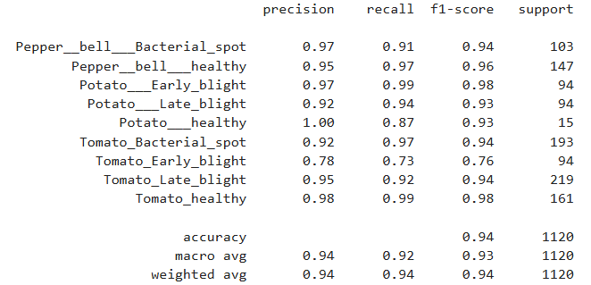
Fig: Classification Report
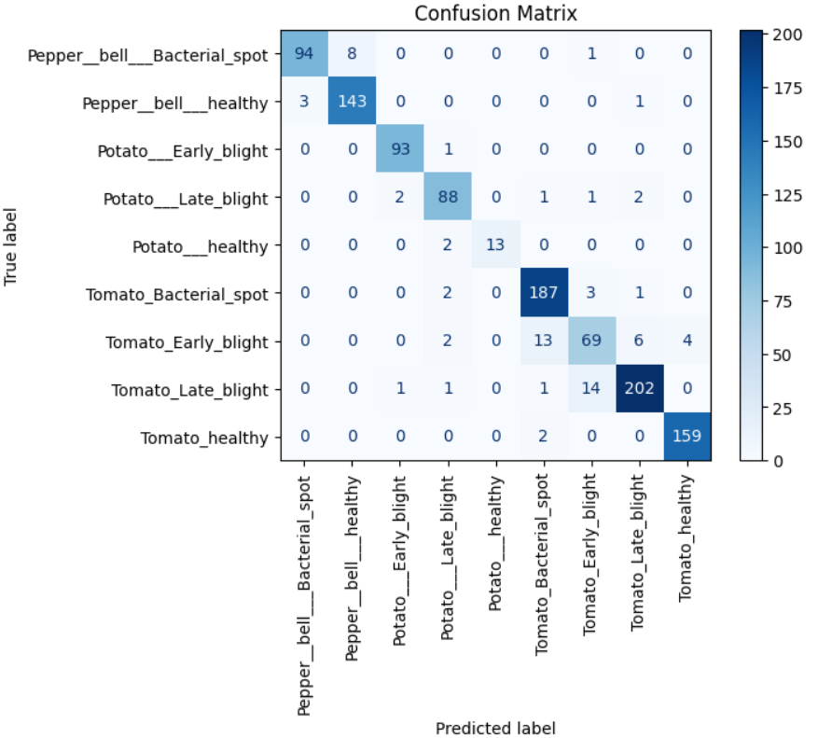
Fig: Confusion Matrix
System Requirements
Hardware:
- CPU: Quad-core or better
- RAM: 8–32 GB
- GPU: Optional but recommended (NVIDIA GPU with CUDA for faster training)
- Storage: 10–50 GB free
Software:
- OS: Windows 10+, Linux, or macOS
- Python: 3.8 or higher
- Libraries: TensorFlow or PyTorch, Numpy, OpenCV, Matplotlib, Scikit-learn
- GPU users: CUDA toolkit

RESULTS
- The model showed good accuracy of 93.5% in detecting healthy and diseased crops.
- Confusion matrix analysis highlighted areas where similar diseases were occasionally misclassified, providing insights for further model improvements.

CONCLUSION
The use of MobileNetV2 as a frozen feature extractor demonstrated that transfer learning is effective for multi-class plant disease detection. Limitations include misclassification in cases of subtle disease symptoms. Future work may include fine-tuning, data augmentation, and testing more complex architectures.
This research demonstrates that deep learning models like MobileNetV2 can accurately detect and classify plant diseases, offering a promising tool for precision agriculture. The trained model, plant_model.keras, can be deployed for real-time disease monitoring.

References
- Hughes, D. P., & Salathé, M. (2015). An open access repository of images on plant health to enable the development of mobile disease diagnostics.

